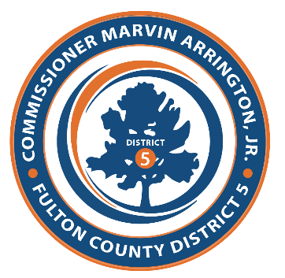
Commissioner Marvin S. Arrington, Jr. Proclamation Request
Please complete this form in its entirety. All Proclamations Requests should be received 30 days before event. A completed form does not constitute confirmation that a Proclamation will be granted. A staff member will send a confirmation email upon approval. Please email verbiage for Proclamation with this form. If there is any event or program literature, please attached with this form.
- Name of Honored Organization: Click or tap here to enter text.
- Name of Honored Person (s): Click or tap here to enter text.
- Named of Honored Event or Occasion: Click or tap here to enter text.
- Date to be printed on Proclamation: Click or tap to enter a date.
- When Proclamation is due: Click or tap to enter a date.
- Will this proclamation be picked up? Choose an item.
- Should Proclamation be presented at BOC meeting: Choose an item.
- Should Proclamation be presented at event by Commissioner: Choose an item.
- If so, please provide the following:
  - Location:Click or tap here to enter text.
  - Address:Click or tap here to enter text.
  - Event Time:Click or tap to enter a date.
  - Proclamation Presentation Time:Click or tap here to enter text.
  - Will there be assigned parking:Click or tap here to enter text.
  - Will there be a meal provided:Choose an item.
  - Will there be photography:Choose an item.
  - Are other elected officials speaking:Choose an item.
  - If so, who:Click or tap here to enter text.
  - Point of Contact (POC):Click or tap here to enter text.
  - Phone Number for POC:Click or tap here to enter text.

Please adhere to the following name format for publicity or promotion materials:
Commissioner Marvin S. Arrington, Jr.

